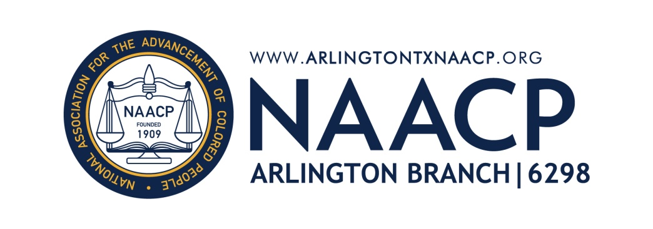

The Arlington ISD and Partners Announce Inaugural
AISD Back to School Kickoff at AT&T Stadium
For the first time, Arlington partner organizations combine efforts to host one collaborative event to help thousands of AISD students and their families get ready to go back to school.

Arlington, TEXAS (May 7, 2015) – Representatives from a multitude of Arlington organizations announced Thursday that together they will host the inaugural AISD Back to School Kickoff on Sat., Aug. 15, 2015 at AT&T Stadium in Arlington. The event will help 15,000 Arlington ISD students and their families get the supplies and resources they need to be ready for the 2015-2016 academic year.

The AISD Back to School Kickoff event will be hosted by the Arlington Independent School District and co-hosted by the Arlington NAACP, Junior League of Arlington, Churches of Arlington, The Gene and Jerry Jones Family North Texas Youth Education Town, and the Gene and Jerry Jones Family Arlington Youth Foundation. The collaboration is intended to maximize each organization’s resources in order to reach the most students in need.

“We believe that an engaged community is essential. With nearly 70 percent of our students being economically disadvantaged, this partnership will allow thousands of them to receive a backpack and needed school supplies prior to the start of school,” said AISD superintendent Dr. Marcelo Cavazos. “Removing barriers for our students and families is key to ensuring a successful year and future for our students.”

At the AISD Back to School Kickoff, which will be held from 8:00 a.m. to noon on the west outdoor plaza and indoor platform of AT&T Stadium, pre-registered students will receive a backpack filled with school supplies appropriate to their grade level, as well as the opportunity to visit a variety of resource booths. Booths will include an immunization station, vision checks, eyeglasses fittings, information on after-school care programs and more.

Students and parents will also be encouraged to attend workshops led by the Arlington NAACP. Workshop topics will include college readiness, testing tips and more. Those who attend will be eligible for exclusive prizes.

"We want students and parents to understand that student success is a team effort between their child's school and families. Therefore, in addition to providing students with school supplies, we are offering workshops geared toward parents and some aimed at students at which they can learn more about very important topics such as: STAAR Testing standards, policies and rankings, literacy, in addition to student and parent responsibilities", said Alisa Simmons, president of Arlington NAACP.

Additionally, AISD Back to School Kickoff attendees can expect to see appearances by Dallas Cowboys mascot Rowdy, Dallas Cowboys Cheerleaders and former Dallas Cowboys players. In addition to the donation of AT&T Stadium as the event’s venue, the Gene and Jerry Jones Family Arlington Youth Foundation donated a $50,000 grant to support the initiative.

“We are honored to be part of a powerful collaboration that will make such a widespread impact on the Arlington community,” said Dallas Cowboys executive vice president and chief brand officer Charlotte Jones Anderson. “It is so inspiring when organizations come together and combine their strengths, assets and resources to make an even bigger difference than we could by working on our own.”

To be eligible to attend the AISD Back to School Kickoff, students must qualify for the free or reduced-price meal program. Parents are required to pre-register their students by visiting www.aisd.net/kickoff. Transportation is available for pre-registered attendees and should be requested via the online registration form.

Arlington community members and supporters may donate to the AISD Back to School Kickoff by visiting the event website, www.aisd.net/kickoff. A donation of $20 provides one student with a backpack and the supplies he or she needs for a full school year. Churches of Arlington, a coalition of churches that serve the Arlington community, and their congregations are driving the fundraising effort.

“One of the great delights of this process is to watch the churches of Arlington band together for something significant. While all of us have been doing a lot individually, I am excited to see what we are able to do together. We believe that education is so important to the future of our city; therefore, we are grateful to play a part in providing the supplies needed for these kids' success,” said Gary Smith, senior pastor of Fielder Church in Arlington.

The Junior League of Arlington, with its more than 500 members, will play a key role in providing volunteer manpower for the AISD Back to School Kickoff event.

“Volunteers bring smiling faces and open hearts to every cause, which helps to provide dignity where there may be little, and hope where it may be lost. They are the uniting force for executing meaningful and impactful community events. As a volunteer training organization, Junior League of Arlington members are dedicated to creating positive change within the local community and we are thrilled to have the opportunity to impact so many families with this event,” said incoming Junior League of Arlington president Emily Swanson.

To learn more about the AISD Back to School Kickoff, including updates on participating vendors and how to get involved, visit www.aisd.net/kickoff.

About the Arlington Independent School District
The Arlington ISD is a public school district in north Texas serving more than 64,000 students. The boundaries encompass most of the city of Arlington, Dalworthington Gardens, Pantego and sections of Grand Prairie. Arlington schools prepare students for future employment and higher education through challenging academic programs and extracurricular activities. Innovative programs, teachers and volunteers are all key to the success of the AISD students. Visit www.aisd.net for more information regarding AISD’s quality programs, activities, faculty and more.

About the Arlington NAACP
The mission of the National Association for the Advancement of Colored People is to ensure the political, educational, social, and economic equality of rights of all persons and to eliminate race-based discrimination. NAACP branches nationwide assist families in their respective communities by holding annual Back-to-School | Stay-in-School Rallies. The recently revitalized Arlington NAACP has hosted it’s Back-to-School | Stay-in-School Rally alongside Arlington City Council Member Robert Rivera since 2013, providing motivational speakers, parent and student workshops, and resource fairs in addition to school supplies and backpacks to more than 2,000 AISD students each August. www.arlingtontxnaacp.org; twitter.com/ArlingtonNAACP; www.facebook.com/NAACPArlingtonTX

About the Junior League of Arlington
The Junior League of Arlington is an organization of women committed to promoting voluntarism, developing the potential of women, and improving the community through the effective action and leadership of trained volunteers. Originally established as the Service League on July 9, 1975, the league is a member organization of the Association of Junior Leagues International, Inc. A 501(c)(3) organization, the Junior League Arlington reaches out to women of all races, religions and national origins. To learn more about Junior League of Arlington, contact the Junior League of Arlington Center for Community Service at 817-277-9481 or visit www.jlarlington.org.

About Churches of Arlington
The Churches of Arlington is a collaborative effort of local churches intent on serving the city of Arlington, TX with greater effectiveness. The churches, including some of Arlington’s largest and most established, have joined forces for the greater good of the community without recognition for any individual organization. The group’s first initiative, called Operation Excel, will begin Summer 2015 in partnership with the Arlington ISD, to provide needed resources to underserved students through the AISD Back to School Kickoff event. For more information, contact Todd Lewis is (817) 459-8519 or visit OperationExcel.org.
Operation Excel is an initiative launched by the Churches of Arlington to provide needed resources to underserved students within the Arlington ISD. Operation Excel’s first campaign is a school supply drive with the goal of collecting 15,000 backpacks stocked with all needed school supplies for a student’s 2015-2016 school year. The backpacks will then be distributed at the AISD Back to School Kickoff at ATT Stadium.

About the Gene and Jerry Jones Family North Texas Youth Education Town
Thanks to a $1 million donation from the Gene and Jerry Jones Family Arlington Youth Foundation in concurrence with a donation from the NFL Foundation, the Gene and Jerry Jones Family North Texas Youth Education Town (the “YET”) opened its doors in October 2013 at The Salvation Army Arlington Corps. The legacy project of Super Bowl XLV, the YET provides educational, arts and athletics programs, including after-school and summer care, for Arlington youth from pre-Kindergarten to high school. The facility is housed at, and operated by, The Salvation Army.

The Salvation Army is a worldwide Christian organization that in the Dallas-Fort Worth Metroplex provides more than 70 different programs and services to help make life better for individuals and families. Services include substance abuse treatment, homeless shelters, life-skills classes, non-perishable food, Christmas gifts for children, disaster relief, a domestic violence shelter, emergency financial assistance, after-school programs, summer day camps, computer training, senior citizens services, and low-cost youth sports activities. Visit www.salvationarmyyet.org for more information.

About the Gene and Jerry Jones Family Arlington Youth Foundation
As part of their commitment to the City of Arlington – home of AT&T Stadium – the Jones family has pledged to donate $16.5 million to organizations supporting Arlington youth over 33 years through the Gene and Jerry Jones Family Arlington Youth Foundation. The foundation’s mission is to enhance the quality of life of youth of the City of Arlington by funding programs and facilities dedicated to football and athletics, health and wellness, education and the arts.

CONTACT:
Alisa Simmons, Arlington NAACP – President@arlingtonTXNAACP.org – 817 939-7288
Leslie Johnston, Arlington ISD – ljohnsto@aisd.net – (682) 867-7201

###

